Configuration and Installation Document for Cognitive Nao Robots



Project Lead: Phil Watson
Authors:
Shoaib Bilal
Andreas Maude

Document Control
ver | Date | Author | Comments
1.0 | 24/05/2016 | Andreas Maude | Doc creation for handover.
1.1 | 30/05/2016 | Andreas Maude
1.2 | 18/7/2016 | Andreas Maude
2.0 | 2/9/2016 | Andreas Maude

Special Thanks To:
Hidemasa Muta
Ann Cho

Contents
Document Control 2
1 Getting Started with Cognitive Nao robots 4
1.1 Registering with Aldebaran 4
1.2 Minimum Software Requirements 4
1.3 Equipment 5
1.4 Taking the Nao out of the box 5
1.5 Turning the Robot On 5
1.6 Connecting to the Robot 6
1.6.1 Connecting the first time 6
1.6.2 Setting Up a WiFi Network to Use Nao Wirelessly 7
2 Basics: Choregraphe 8
2.1 Connecting to the Robot 8
3 Advanced Use of the Nao 9
4 Appendix 10
4.1 System Requirements 10
4.1.1 Hardware 10
4.1.2 Supported Operating Systems 10

Getting Started

Registering with Aldebaran
Before you download any of your software, register yourself on the Aldebaran website. This will make retrieving some of the software much easier.
- Go to Aldebaran Website: https://www.ald.softbankrobotics.com/en
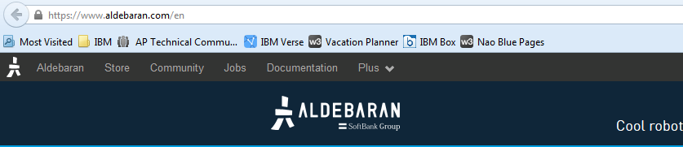
- Click Community

- Click Developers
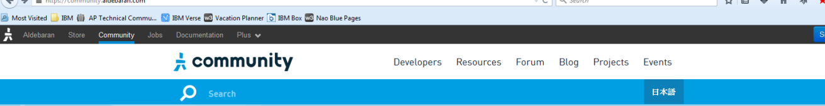
- Click Join
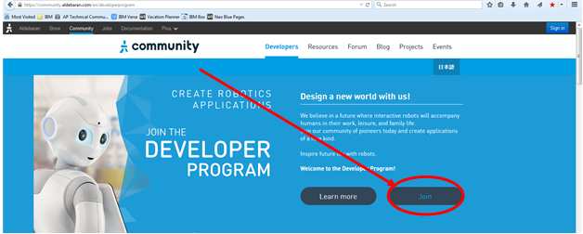
- Click sign in and follow the prompts to register an account
  - Country: America
  - Use: Professional

Minimum Software Requirements
For helpful documentation on all the software listed below that is required to run your Nao, see Documentation. Essential software required is listed below.
- Choregraphe – Download link
  - Choregraphe is the Integrated Development Environment (IDE) for Nao robots. It is simple to use and has an intuitive graphical interface.
- Python 2.7 – Download link
  - IMPORTANT NOTE: You must use Python 2.7. Python 3+ is not supported.
  - Nao’s internal packages are written in C++, but these are accessed in an easy way using Python code. These are some useful Python add-ons to install:
    - pip (automatically accompanies Python 2.7)
    - python image library (pil) – Download link
    - Python-friendly text editor (e.g. Atom – Download link)
- NaoQi – Download link
  - NaoQi is Nao’s operating system (OS). You must have NaoQi installed to use Python to communicate with the robot.
- Node.js – Download link
  - The node.js install files can be found in the …\Naomi\Software\node.js folder.
  - On Windows, simply run the .msi file.
  - On Mac, unzip the .pkg file and run the installer.
- Cloud Foundry CLI – Download link
  - The install files for cloud foundry CLI can be found in the …\Naomi\Software\Cloud Foundry folder.
  - Unzip the right file (.pkg file for Mac, .zip file for Windows) and run the installer.

Equipment
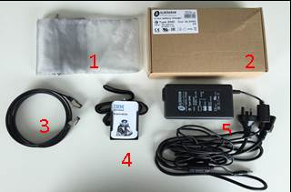
- Grey bag for networking cable
- Storage box for power cables
- Networking cable
- NAO’S I.D. Badge (only if previously ordered)
- Power cable
- External microphone for speech to text (optional)

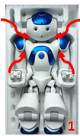
Taking the Nao out of the box
- Gently lift Nao from under each arm and above each shoulder, lifting the torso and head out first, followed by the legs. NB: Support NAO’s head when lifting it out of the box.
- Lay NAO on its back on a flat and stable surface at least 60cm from any edges.
- If there are elastic bands around the fingers, remove elastic bands from each hand placing them back in the polystyrene box. Note: elastic bands are useful for protecting the delicate fingers and should be used when storing the robot.

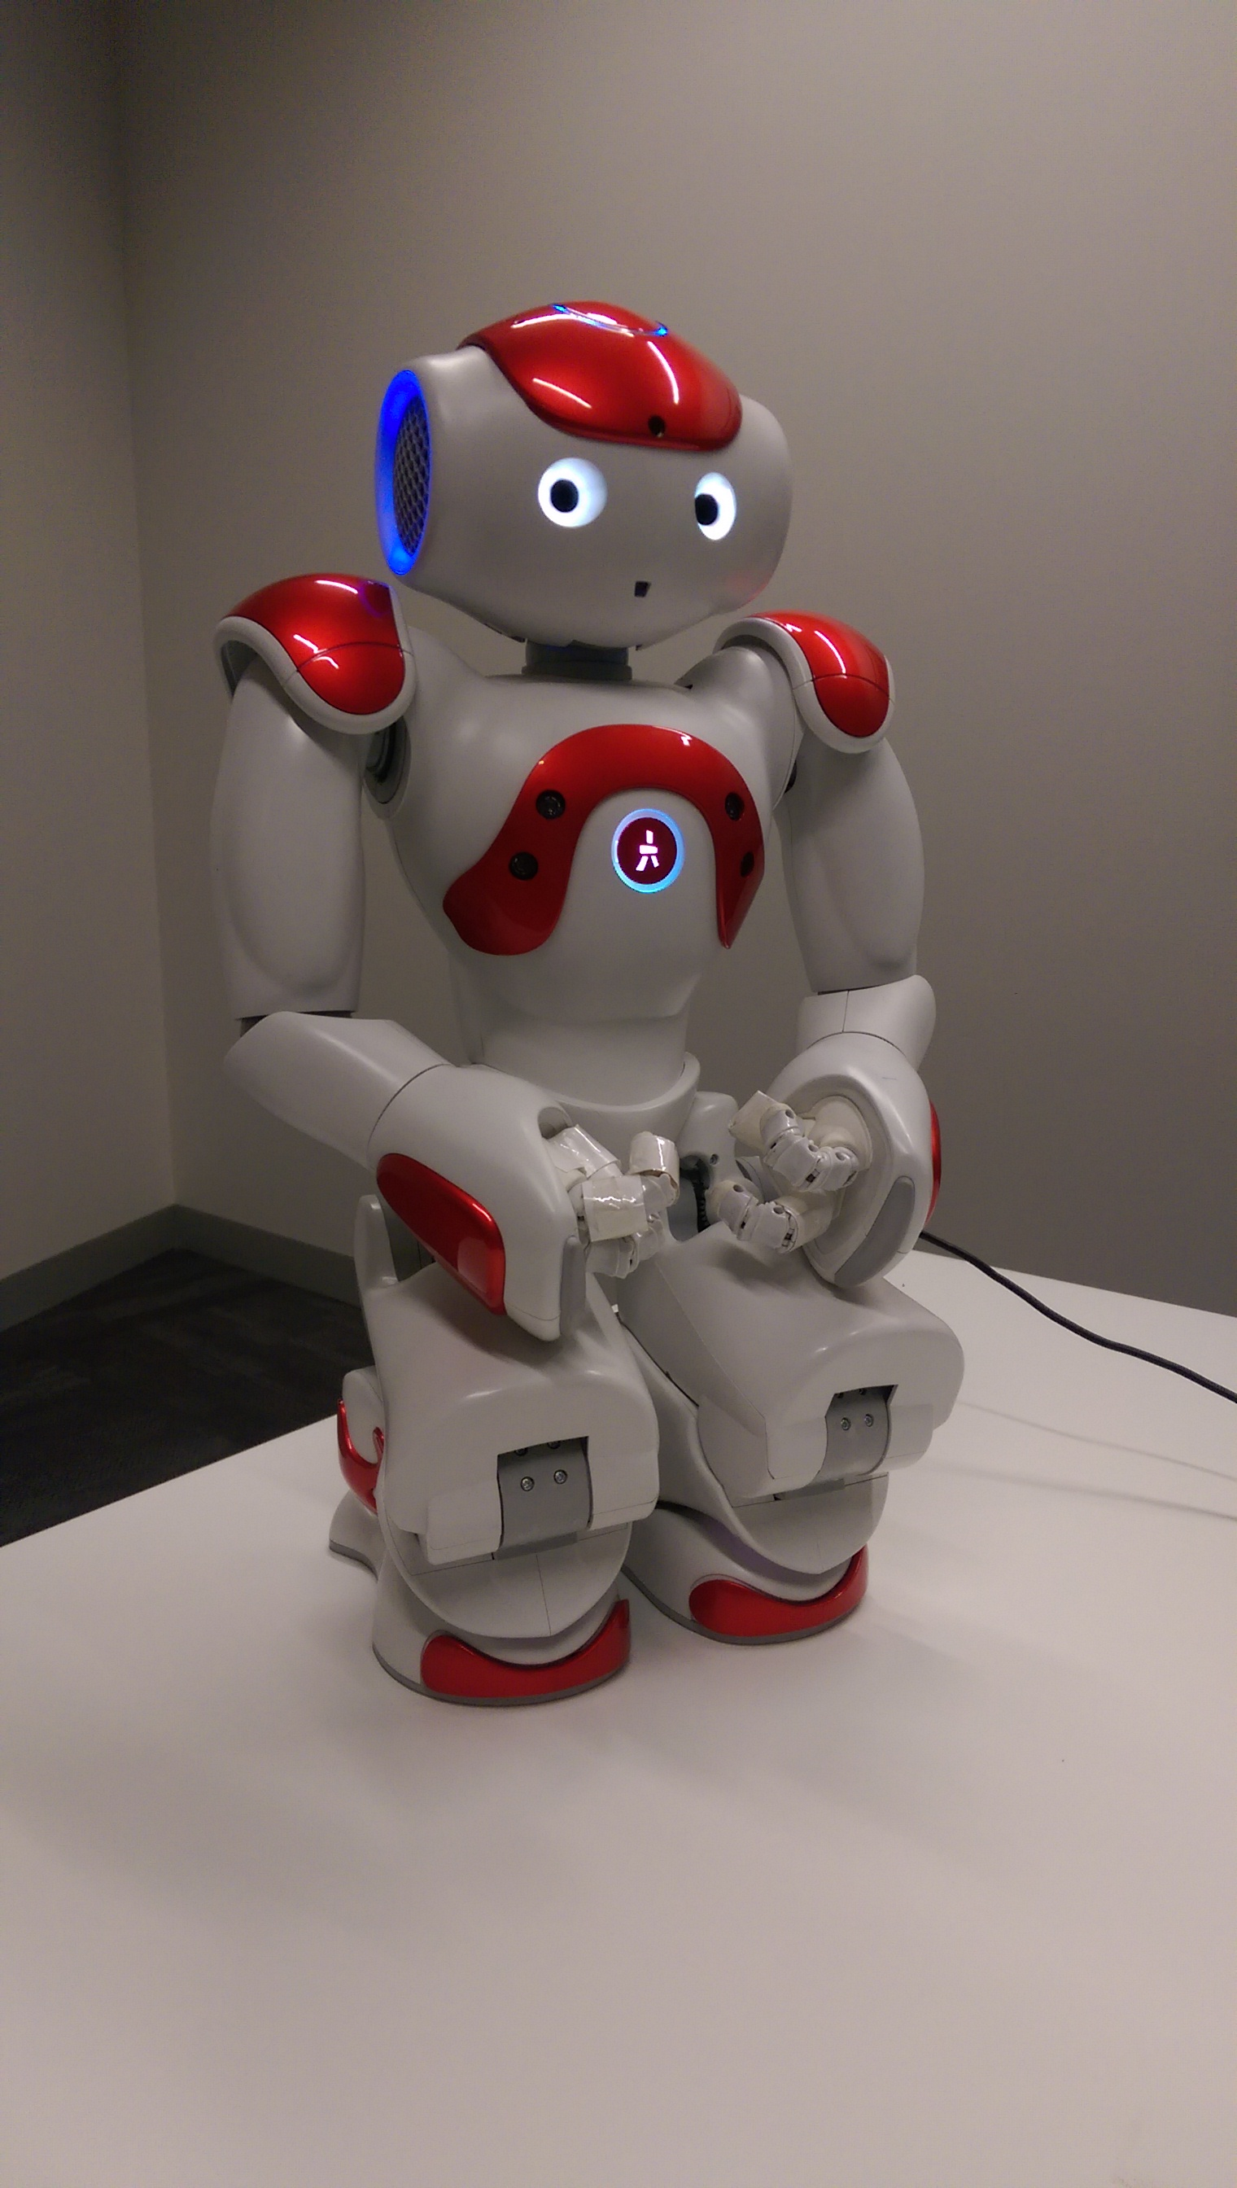
Turning the Robot On
Figure 1 - Starting position
First, ensure that the robot is in an upright, stable position (see Error: Reference source not found), and that the battery has sufficient charge. If you are unsure how much charge the battery has, keep the robot plugged in to the power source while turning on. The charging port is located in the middle of the back of the robot.
To turn the robot on, hold the chest button for ~2 seconds. The lights will turn on. Start-up takes some time. The process is complete when the robot utters its start-up sound, “gnouk, gnouk”, and stands up.

Connecting to the Robot

Connecting the first time
The first time you connect to your robot you will have to use the Ethernet cable. The Ethernet port for the robot is in the back of the head:
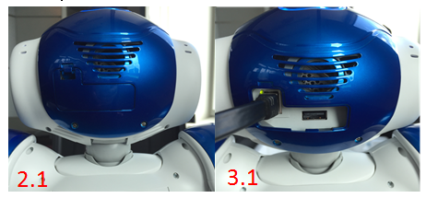
- Connect the Ethernet cable to the Nao robot and to your computer. The robot can take up to five minutes to connect.
- Press the chest button once; the robot will tell you its IP address. If it has not yet connected, it will utter “I cannot connect to the network”. If this is the case, wait a few more seconds and try again.
- If you attempt step 2 three times, NAO will repeat the IP address very slowly in order for the user to hear it clearly.
Once you have it, type the IP address into your browser to connect to the robot webpage (Figure 1). The username and password are “nao”.
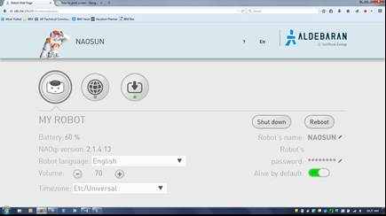
Network settings
Figure 1 - Robot webpage

Configuring the Nao
On the first time connecting to the Nao, you will be prompted to start the configuration wizard. Follow the prompts to set up the language, name, and password of your Nao robot. If required, there is helpful documentation to guide you.

Setting Up a WiFi Network to Use Nao Wirelessly
After you have connected for the first time, you can return to the robot web page to use some basic controls for the robot, such as volume, and setting up new wireless networks. To connect Nao to a wireless network,
- Click the network settings button (see Figure 1),
- In the “Network Settings” page that pops up (Figure 2), click ‘refresh’,
- Click on the desired wireless network and type in the password if required. If successful, it will say “fully connected” below that network,
- You can now remove the Ethernet cable.
Note: once you have removed the Ethernet cable, the Nao will switch networks to the newly configured wireless one. Its IP address will change, and you will have to press the chest button again to hear the new IP address. With the new IP address, you can connect to the robot webpage again as before to confirm that the robot has connected to the new network. Ensure that your computer is connected to the same network as the Nao.
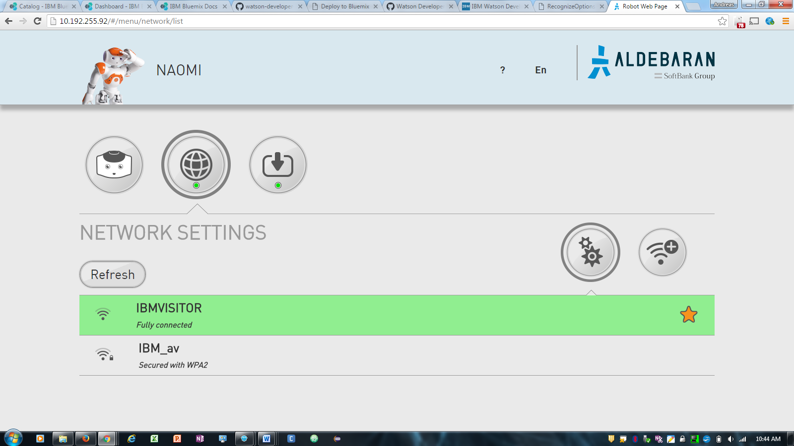
Figure 2 - Network settings page
Security Issues: currently, Nao robots cannot connect to the IBM network due to security certificate issues. A good solution is to connect to the IBM Visitor network. However, in many regions, the IBM visitor network is not strong enough to maintain a good connection to the Nao. In such regions, either remain connected through the Ethernet cable, or use a HotSpot.
Once you have successfully connected the Nao to the correct network, the Nao remembers that network. In the future, it should automatically connect to that network, without requiring you to use the Ethernet cable.

Obtaining the Robot’s IP Address
Once the robot has connected to a network, you will need its IP address to connect to it, as well as have your laptop connected to the same network. To obtain the robot’s IP address, simply press its chest button once, and it will tell you its IP address.

Installing Choregraphe

Basics: Choregraphe
Choregraphe is the basic IDE provided by Aldebaran to create simple, scripted process for the robot. In general, you will not be using Choregraphe to connect the robot to Watson services. Choregraphe is very useful to control some of the fundamental functions of the robot, such as its state (whether or not it is awake or asleep, autonomous life on or off, etc.) and will be important to have a basic understanding of. However, if you intend to work with the more advanced Watson functions, please see Advanced Use of the Nao.

Connecting to the Robot
At this stage, it is assumed that Choregraphe is installed, that you have connected to the robot for the first timeConnecting the first time, and that the robot is connected to a network and has an IP address.
- Launch Choregraphe.
- Obtain the robot’s IP address by pressing the chest button once.
- Press the green ‘connect’ button.
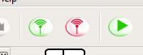
- Click “Use fixed IP/hostname” and enter the robot’s IP address. Ensure that both boxes are ticked and hit “Select”.
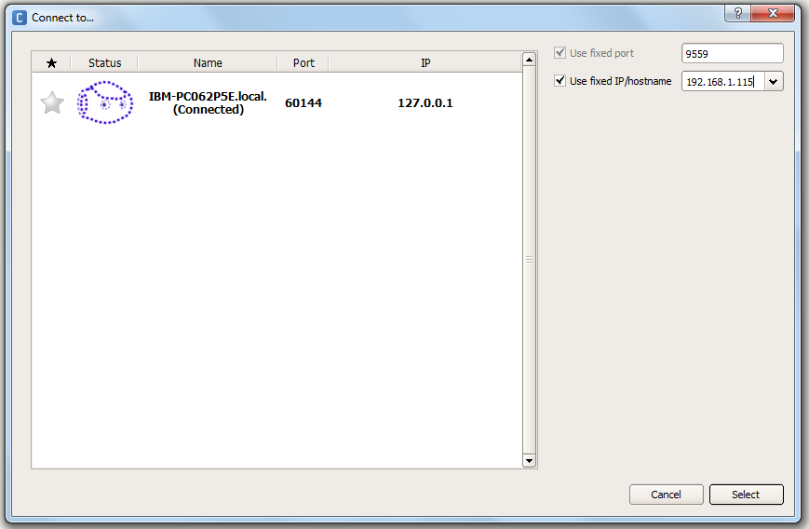
- Check the video monitor to see the Nao’s camera feed and determine if connection was successful.
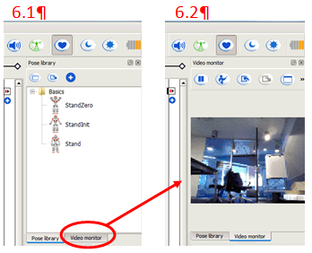

Basic Controls
At this stage, it is assumed that you have launched Choregraphe and are connected to the robot. There are a few key controls available in Choregraphe that are essential for smooth operation of the robot.

Basics: Python
This section deals with the basic commands and communication protocols that you can use to control the robot. It is assumed that you have the relevant Python and NaoQi software installed (see Minimum Software Requirements) and are connected to the robot (optional).

Running Python Code on Command Line
This section will cover only the very basics of running Python scripts through the command line. For more advanced use of Python please consult Python documentation, visit the coding community web pages or investigate learning and training opportunities.

Bluemix

Creating a Bluemix Service and Obtaining Credentials
To use any of the Watson functionality with the robot, you will need to create instances of relevant Watson services on Bluemix and obtain credentials for them.
The instructions below show how to create a Speech to Text service, but the process is identical for any kind of service.
- Log in to Bluemix.
- Select your region by clicking the profile icon in the top right hand side of the screen.
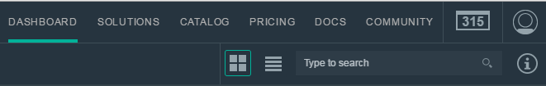
- Go to Catalog in the top navigation bar. Once in the catalogue, select Watson in the left-hand pane under Services.
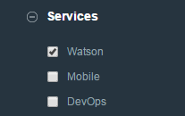
- Select Speech to Text.
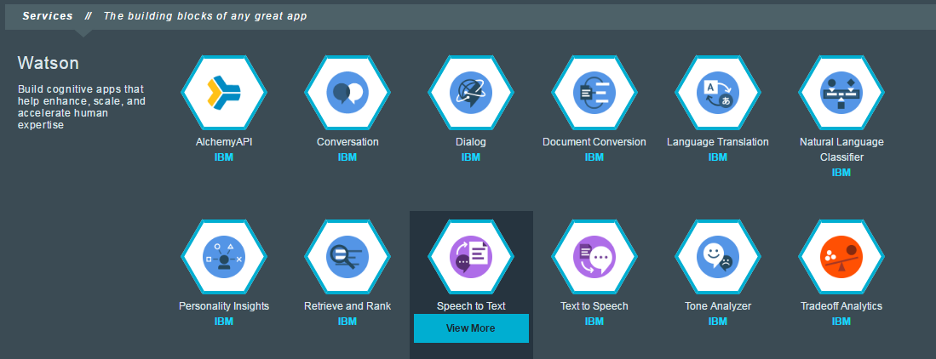
- Type in the name that you want to give to your service and hit “Create”. You can leave the service unbound, or bind it to an app – for the Naomi project, it is unimportant.
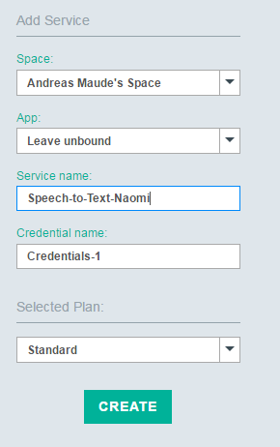

- Wait for the screen to refresh and obtain the credentials for your new service by clicking Service Credentials on the left hand pane of the screen.

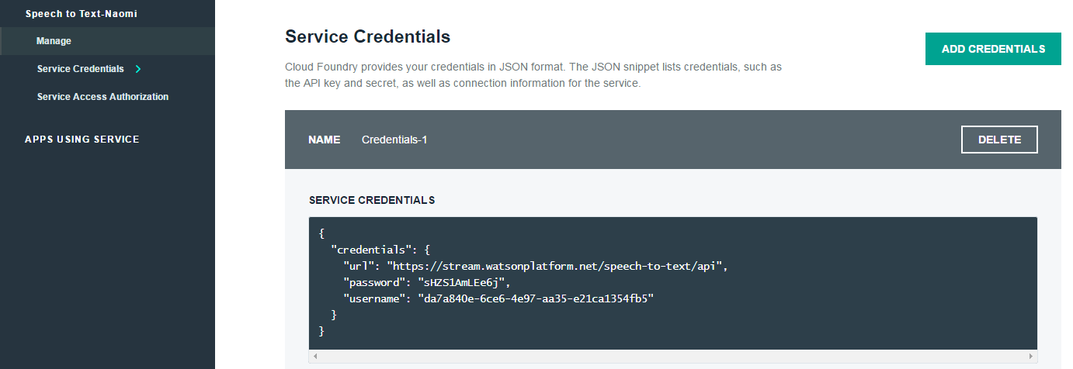
- Manually copy & paste Speech to Text credentials to the correct place in the app.js file in the main project, …\Naomi\Speech to Text\app.js (lines 41 & 42).
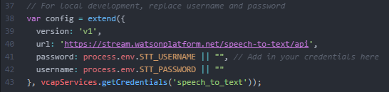
- For all other credentials, copy & paste them to …\Naomi\Config\CreateCredentialsJson.py
  - Ensure that you obey the correct formatting rules as laid out in the example within the file.
  - Add the credentials to the correct region. This allows you to have multiple credentials in different regions.
  - Run the CreateCredentialsJson.py file on command line. This creates a .json file with all your credentials in it that the main project file will automatically access.

Advanced: Nao Python Project
This section deals with the main Naomi project. It is assumed that all minimum software requirements have been met (see Minimum Software Requirements), that you have managed to connect to the robot (not required), that you have a Bluemix account, and that you are familiar with using a terminal/command line.

Overview of Steps to be Taken Prior to Running the Naomi Project
- Download the Naomi project folder to a desired directory on your computer.
- Create services and obtain Bluemix credentials for minimum required Watson services.
- Visual Recognition
- Natural Language Classifier
- Speech to Text
- Conversation (optional)
- Take note of the region in which you create your Watson services, you will need this information when copying & pasting your credentials, and in your configuration file.
- Add the credentials to the project files (see steps 7 & 8 in Obtaining Credentials).
- Train your Natural Language classifiers (for help see Using the NLC Service).
- Write responses to each NLC intent in the …\Naomi\Resources\NLC\Responses .csv files.
- Train your Visual Recognition classifiers (for help see Using the Visual Recognition Service). This step is optional.
- Put necessary information in the configuration file.
- Set up equipment (robot, external microphone).
- Obtain the Nao robot’s IP address (if a robot is present).
- Start up the main project code.
- Start up the speech to text app (not required).
Once you have completed these steps, you are ready to run the robot demo. You can move on to the next chapter, Using the Naomi Project.

Project Components
The project consists of two main components, which in turn contain several sub-components. The two main components are
- Speech to Text,
- Naomi Project (includes all robot and Watson functions)
These two components run independently of each other, and run through separate command lines/terminals.
The Naomi Project has the following sub-components
- The main project code: Naomi.py,
- Code with robot functions: PythonForNaomi\RobotFunctions.py
- Watson Natural Language Classifier, which you can administrate using NLCAdmin.py,
- Watson Visual Recognition, which you can administrate using VRAdmin.py,
- Your Bluemix credentials, which you store using Config\CreateCredentialsJson.py,
- Configuration parameters for the demo, which you can change in Config\Robot Configuration.txt,
- And a Resources folder

Speech to Text
The Speech to Text app is simply an instance of the Bluemix demo app for Speech to Text running locally on your computer.
To run this app successfully, you will need to run it on Google Chrome, and have Node.js installed.
The code for this app lies in the …\Naomi\Speech to Text folder, and was initially obtained from Github.

Creating the Service
First you will need to create your own instance of Speech to Text on Bluemix. You can either go to Bluemix and follow the instructions in this document, or use the Cloud Foundry CLI with instructions here.
If using the Cloud Foundry method, you will need to have Cloud Foundry installed.

Installing Dependencies
After creating the service, you will need to install the dependencies of the app. In your terminal, navigate to the …\Naomi\Speech to Text folder and run the command
npm install

Running the App
Once the service has been successfully created, your credentials added to the code and the dependencies installed, you are ready to run the app. Open your terminal and navigate to the …\Naomi\Speech to Text folder.
The command to run the app is
npm start
If successful, the terminal should display following message:
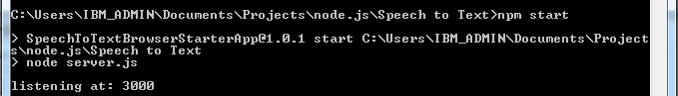
You must then open Google Chrome and head to http://localhost:3000/, where the app is running. You will see this screen:
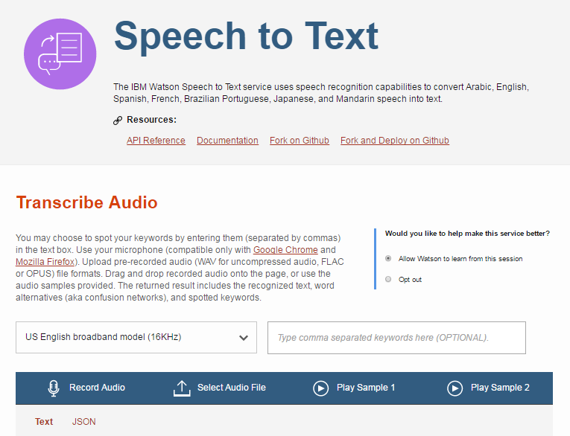
Hit the Record Audio button to start recording audio. The app should automatically recognise and request access to any external microphones that you have connected to your laptop. Start speaking into the microphone. You will see your transcript come up on screen, as well as text files being downloaded. You may have to allow the site to make multiple downloads.

Set the Default Download Directory
The Naomi project runs by detecting text file downloads from the speech to text app. It is therefore imperative to the running of the project that the default download directory for Google Chrome is …\Naomi\Resources\Transcript Text Files. You can find instructions to change the default download directory here.

Naomi Project

Naomi.py
This is the main project file. Run it from the terminal to start the project. The command to run it is
python Naomi.py
The program will ask you to specify whether or not a Nao robot is present and connected – the code will run smoothly with or without a robot. Press ‘y’ or ‘n’ followed by enter to make a selection (‘y’ = yes, ‘n’ = no). If you select yes, a second question will ask you to verify the robot’s IP address (see Obtaining the Robot’s IP Address).
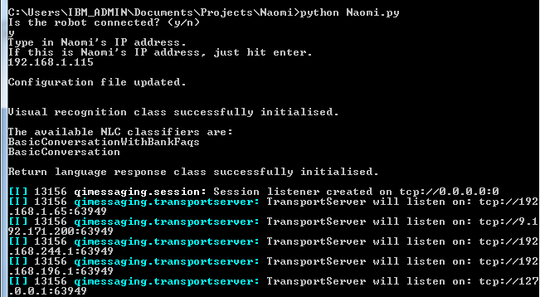

Robot Functions
…\Naomi\PythonForNaomi\RobotFunctions.py contains code for various robot functions the robot can perform. This includes physical tasks such as lying down, standing up, taking a picture, etc.
Any new functions to be written that contain commands to the robot and should be able to be called verbally using NLC should be placed in this file.

Credentials
Credentials for Watson services used by the project are stored in …\Naomi\Config\credentials.json. This makes handling different credentials easy. To add your credentials to the .json file, copy & paste the credentials from Bluemix to the …\Naomi\Config\CreateCredentialsJson.py file, and run
python CreateCredentialsJson.py
from the command line in the config directory. See steps 7 & 8 in Obtaining Credentials.

Configuration
You can customise much of the way the project runs in the Robot Configuration.txt file in the config folder. In the configuration file, words that start with an underscore indicate variables that can be modified.
When changing a variable, you must follow the correct syntax, which is _variableName, colon, space, value. E.g. _speechSpeed: 87
The variable name is speechSpeed and the value is 87.

Initial Configuration
Most of the values in the configuration file have default values, but there are some that must be set before you can use the project for the first time.
- Open up …\Naomi\Config\Robot Configuration.txt
- Replace the ‘ADD_IN_YOUR_CLASSIFIER_NAME_HERE’ with the relevant classifier name for the specified service (NLC or visual recognition), and add the region that your service was created in.
- For NLC, add in the firstNlc and regionNlc variables like so:
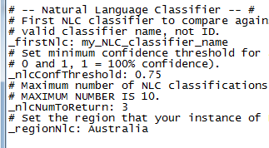
- For Visual Recognition, add in the vrClassifierName and regionVr similarly:
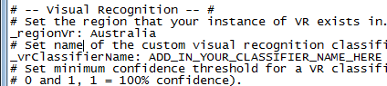

Using the Natural Language Classifier (NLC) Service
At this stage, it is assumed that you have Bluemix credentials for an NLC service and have added them to the credentials .json file. You also have a basic understanding of how the NLC service works. For help with the NLC service, see the Documentation.

Overview of the Natural Language Processing
The process by which you communicate with the robot is quite simple.
- Input user text.
  - This is either verbal (when using speech to text) or typed (if not using speech to text)
- The user text is uploaded via an API call to Watson NLC service and compared to a specific classifier (it is possible to have multiple trained classifiers).
- The API call returns the intent of the user text, as calculated by Watson NLC.
- This intent is compared to a dictionary of responses that is stored in the Naomi project, and the correct response returned. These responses are set by the administrator.
- If a robot is connected, the robot speaks the response. Otherwise, the response is displayed on screen.

Administration of the nLC Service
The Naomi project has a basic program for keeping classifiers up to date, which is run from a terminal window. To run it, navigate to …\Naomi\NLCAdmin.py in the terminal and run the command
python NLCAdmin.py
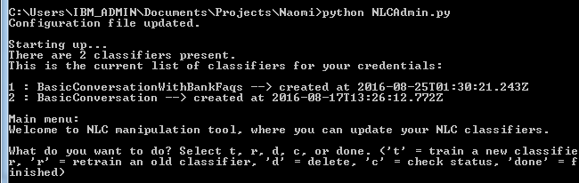
You can use this program to train, re-train, delete, and check the status of your trained NLC classifiers. Type in the corresponding letter and press enter.

Creating and Training Classifiers
…\Naomi\Resources\NLC\Training is the folder that contains training files for your NLC service. Some training files are provided with the project – feel free to use these as ‘starter packs’ for your own instance of NLC. They contain training example sentences for many basic robot commands, such as ‘sit down’ or ‘stand up’, which are useful to all robot applications.
To create your own classifiers, simply create a new .csv file with your intents and example sentences. You are able to train multiple classifiers, and even switch between classifiers during the running of the main project. More information on switching classifiers can be found in the responses section.

Storing Classifier IDs
The Watson NLC service uses a classifier ID to identify the classifier against which you want to classify a sentence. The NLCAdmin.py program automatically stores these classifier IDs for the main project to access. To do this, simply write ‘done’ and press enter when you are done with using the program (i.e. do not early exit the program by pressing ctrl+c, unless there is some error).
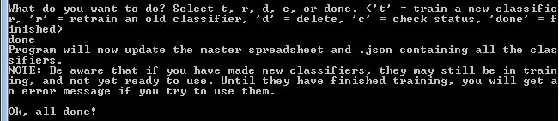

Response .csv Files
…\Naomi\Resources\NLC\Training\Responses is the folder that contains response files.

Naming Convention
The response files must be named the same as the corresponding NLC classifier, but preceded by ‘R’. E.g. you might create a training file called classifier1.csv. The NLC classifier name will be classifier1, and the response file must be called Rclassifier1.csv. This is due to the way in which the response dictionary is created in the main project.

Set Up
Response files are set up in the following manner:
Classification | NextClassifier | Response1 | Response2, 3, 4…
The intent returned from the NLC API call for which a response is sought | If the classifier ID should change for the next API call, this call contains the name of the next classifier | The verbal response that should be returned for the intent given in column 1 | Alternative responses to be selected randomly (not yet functional)
This gives flexibility in the manner with which you can classify your input text/speech. You can set up separate classifiers to handle different parts of a conversation, and have intents from the first classifier lead to using a different classifier for the next API call. This sort of flexibility is also possible when using the Watson Conversation service.

Using the Visual Recognition Service

Using the Naomi Project
At this stage, it is assumed that you have set up the project completely as set out in Advanced: Nao Python Project, and that the main project code is running.

Functional Overview
This overview should provide you with a basic understanding of how the project functions. The project can function with or with a robot, and with or without the speech to text app.
- Input user text/speech.
- User text is uploaded via an API call to Watson NLC service and compared to the specified classifier (it is possible to have multiple trained classifiers).
- The API call returns the intent of the user text, as calculated by Watson NLC.
- This intent is compared to a dictionary of responses that is stored in the Naomi project, and the correct response returned.
- If a robot is connected, the robot speaks the response. Otherwise, the response is displayed on screen.
- The returned intent is checked against a dictionary of robot functions to see if the robot should commit an action.
- The returned intent is checked against a dictionary of Watson functions to see if another API call should be made (e.g. visual recognition).
- Once the robot has spoken its verbal response and completed any robot or Watson functions it was commanded to, it will go back into listening mode, waiting for the next user input.

Inputting User Text
There are two ways to input user text; through the speech to text app, or by typing.

Appendix

System Requirements

Hardware
A computer connected to an open WiFi access point, with:
- 1.5 GHz CPU
- 512 MB RAM
- a certified OpenGL graphics card

Supported Operating Systems

OS | Version
Linux | Ubuntu 12.04 LTS (Precise) and later
Windows | Microsoft Windows XP Service Pack 3,  Microsoft Windows 7 and 8
Mac | Mac OS X version 10.7.1 Lion  Mac OS X version 10.8.3 Mountain Lion

Software Requirements
See Minimum Software Requirements.

Bluemix Services
Table 1 - Links to documentation for Watson services
Service | Documentation | Demo | API Reference
Speech to Text | Documentation | Demo
Visual Recognition | Documentation | Demo | API Reference
Personality Insights | Documentation | Demo | API Reference
NLC | Documentation |  | API Reference
Conversation | Documentation |  | API Reference

